NAME: ARCHIT VERMA

Roll no. 2428cse1856S

Section: CSE ‘B’

Mobile : 7900974176

Experiment 1 HTML Basics

Top of Form

Bottom of Form

Static home page Assignment 1

1. Create Basic HTML page and demonstrate <p>, headings <br>, <hr> tags.

Code:

<html>

<head>

<title> my first page</title>

</head>

<body>

<h1> Learning Web d </h1>

<hr style="height:2px;border-width:0;color:gray;background-color:gray">

<P><h3> Hello Ji this is my first web page, I am enjoying it.</h3> </p>

Thankyou <br>Have a Goodday.

**Output:**

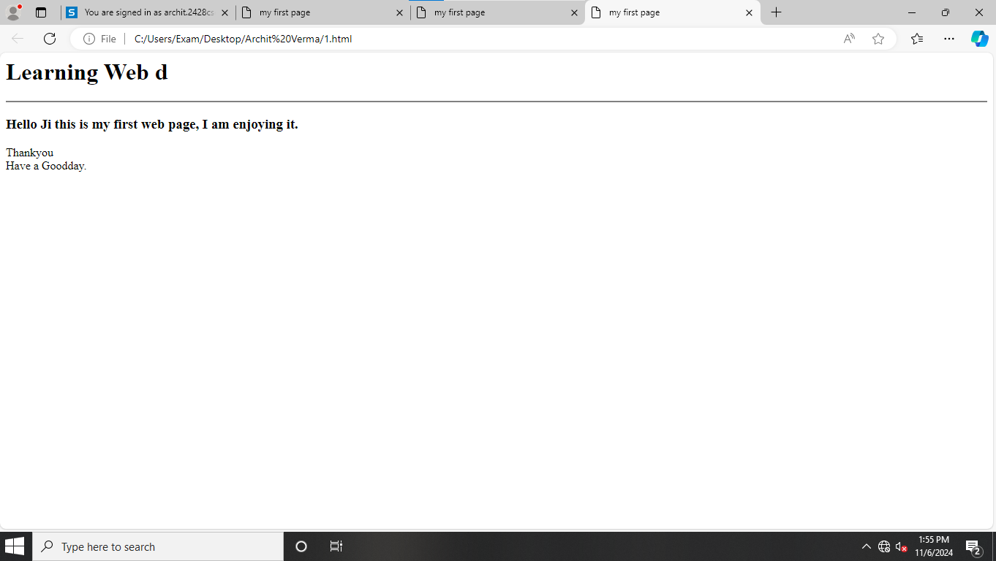

2. Create a Basic HTML page and demonstrate <img>, <ol> <ul>, <a> tags.

Code:

<html>

<head>

<title> Archit Verma </title>

</head>

<body>

<h3> Using image tag, and making ordered and Unordered list, also Hyperlink</h3>

<ul>

<li>Saffron<img src="https://i.pinimg.com/564x/ea/14/0a/ea140a9f6e4681b64b35262cf873f026.jpg" width="200 height="200" style="horizontal-align:right"></li>

<li>White</li>

<li>Green</li>

<a href="https://i.pinimg.com/564x/ea/14/0a/ea140a9f6e4681b64b35262cf873f026.jpg">Image link

</a>

</ul>

<ol>

<li>Apple <img src= "https://img.freepik.com/free-vector/shiny-red-apple-vector-illustration_1308-165590.jpg" width="100" height="100" style="horizontal-align:right"></li>

<li>Mango<img src= "https://t3.ftcdn.net/jpg/01/36/33/48/360_F_136334861_pBHpG4hSvyN66ddSqs0ddtKXG8Eoq3NW.jpg" width="100" height="100" style="horizontal-align:right"></li>

<li>Guava<img src= "https://www.shutterstock.com/image-vector/summer-tropical-fruits-healthy-lifestyle-600nw-1007413960.jpg" width="100" height="100" style="horizontal-align:right"></li>

</ol>

<a href ="https://img.freepik.com/free-vector/shiny-red-apple-vector-illustration_1308-165590.jpg">Apple Image link</a><br>

<a href ="https://t3.ftcdn.net/jpg/01/36/33/48/360_F_136334861_pBHpG4hSvyN66ddSqs0ddtKXG8Eoq3NW.jpg">Mango Image link</a><br>

<a href ="https://www.shutterstock.com/image-vector/summer-tropical-fruits-healthy-lifestyle-600nw-1007413960.jpg">Gauva Image link</a>

</body>

</html>

Output:

